Train Management System

**Installation steps:**

1. The GUI library used in tkinter which comes pre-installed with Python3. Make sure you have python3 installed in your system.
2. Open the folder containing all three files “CreateDB.py”, “Queries.py” and “Code.py”. Use command “python3 code.py” to start the application.
3. If the database “trainsdb.db” is not present in the folder, click on the button “Create sample db” to create the database for further steps.

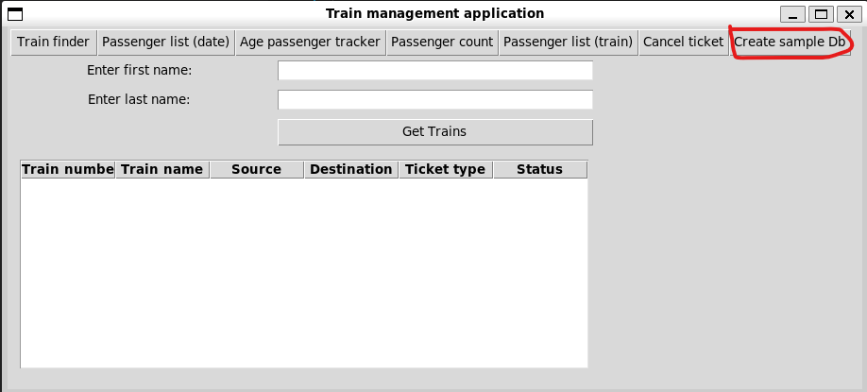

**QUERY 1**

**User input the passenger’s last name and first name and retrieve all trains they are booked on**

1. Click on train finder button from the menu.
2. Enter the first and last name of the user and click on the Get Trains button to see a list of all the trains the user is booked on.

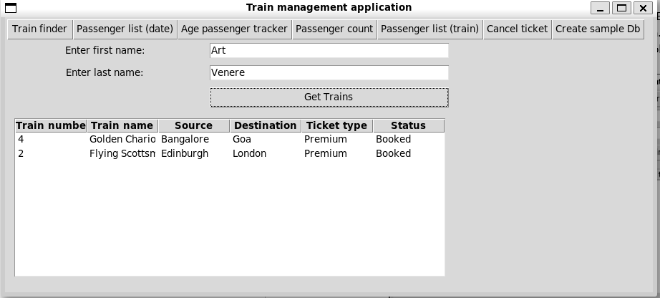

**QUERY 2**

**User input the Date and list of passengers travelling on entered day with confirmed tickets displays on UI.**

1. Click on Passenger finder(date) button from the menu.
2. Enter the date of travel (yyyy-mm-dd).
3. The GUI displays the required list

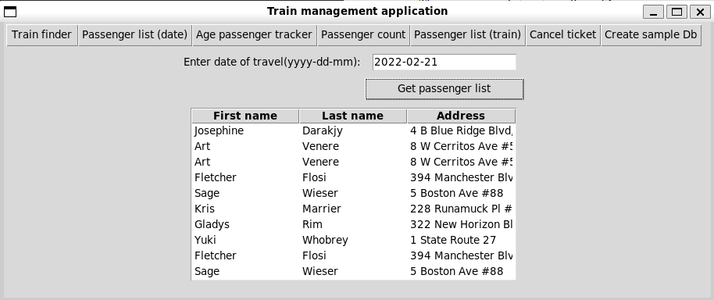

**QUERY 3**

**User input the age of the passenger (50 to 60) and UI display the train information (Train Number, Train Name, Source and Destination) and passenger information (Name, Address, Category, ticket status) of passengers who are between the ages of 50 to 60.**

1. Click on Age passenger tracker button from the menu.
2. Enter the range of age in the respective fields and click on get trains button.
3. The GUI displays the required results

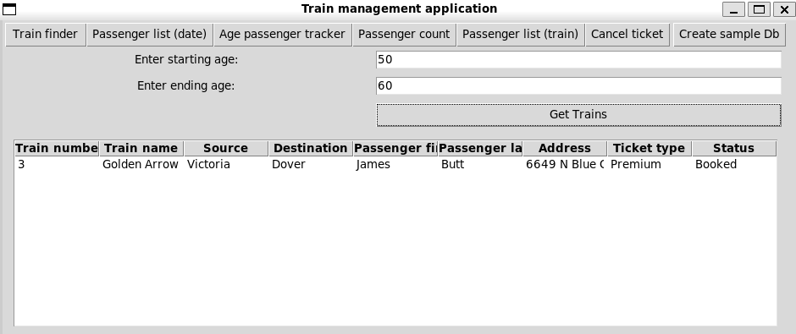

**QUERY 4**

**List all the train name along with count of passengers it is carrying.**

1. Click on the passenger count button to get the list of all the trains.
2. Count of passengers is counted as sum of general seats booked and premium seats booked in a train.

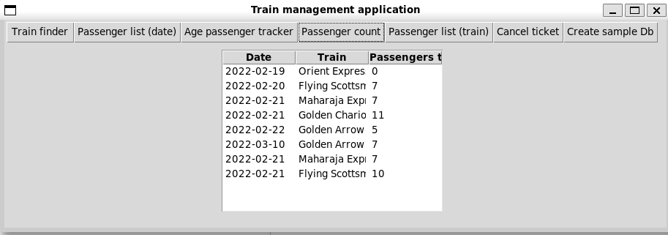

**QUERY 5**

**Enter a train name and retrieve all the passengers with confirmed status travelling in that train.**

1. Click on the passenger list (train) button.
2. Type the name of the train to see the list in the GUI

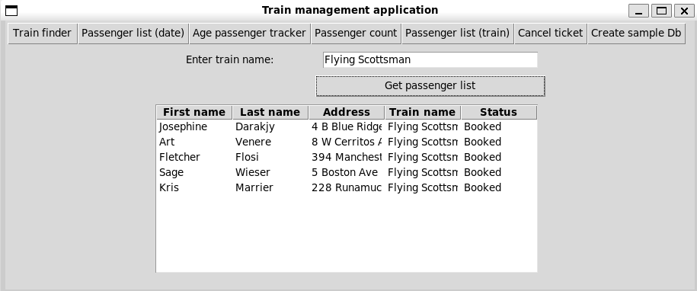

**QUERY 6**

**User Cancel a ticket (delete a record) and show that passenger in waiting list get ticket confirmed.**

1. Click on the Cancel ticket button and enter the Passenger SSN and train number to cancel the ticket
2. One person from the waitlist with the same category ticket will get confirmed ticket.
3. To see it working, let’s cancel ticket of Josephine Darakjy from the train Flying Scottsman.

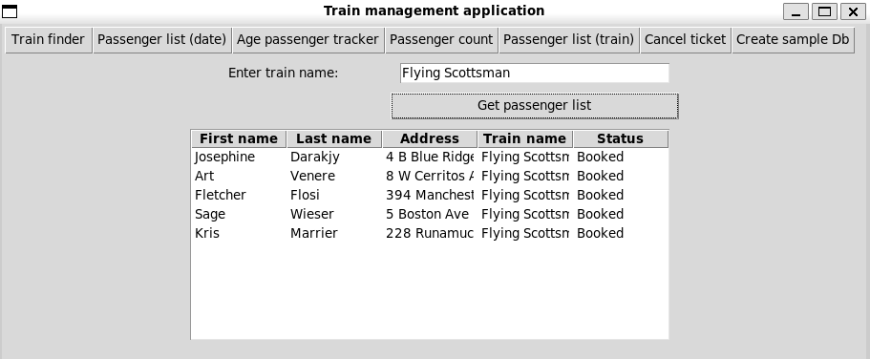

Figure 1: Initial Passenger list

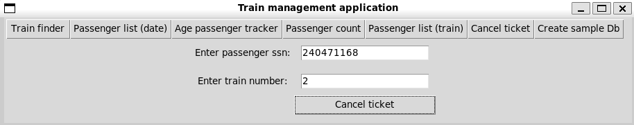

Figure 2: Adding details of Josephine Darakjy to cancel ticket

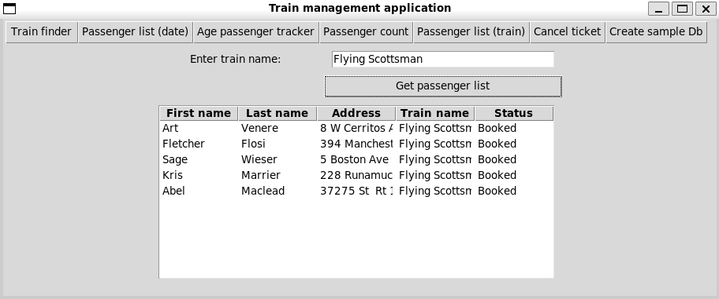

Figure 3: Ticket of Abel Maclead got confirmed (last row)